
Princess Nora Bint Abdulrahman University Course: Data Structures (CS322)
College of Computer and Information Sciences

Sheet Binary tree

Question # 1: circle the correct answer:

- Consider this binary search tree:
14
/ \

2 16
/ \
1 5
/
4
Suppose we remove the root, replacing it with something from the left subtree. What will be the new root?

A. 1
B. 2
C. 4
D. 5

Consider this binary search tree:

14
/ \

2 11
/ \ / \

1 3 10 30
/ /
7 40

- What is the order of nodes visited using a pre-order traversal?

A. 1 2 3 7 10 11 14 30 40
B. 1 2 3 14 7 10 11 40 30
C. 1 3 2 7 10 40 30 11 14
D. 14 2 1 3 11 10 7 30 40

- There is a tree in the box at the top of this section. What is the order of nodes visited using an in-order traversal?

A. 1 2 3 7 10 11 14 30 40
B. 1 2 3 14 7 10 11 40 30
C. 1 3 2 7 10 40 30 11 14
D. 14 2 1 3 11 10 7 30 40

Question # 2: answer the following:
answer the following:
For the following complete binary tree :
  - Draw how this binary tree can be implemented as a linked list.
  - Draw how this binary tree can be implemented as an array (using the usual array representation of a complete binary tree).
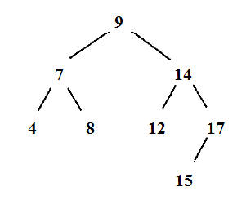
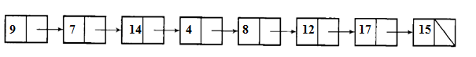
index | Data | Left | right
0 | 9 | 1 | 2
1 | 7 | 3 | 4
2 | 14 | 5 | 6
3 | 4 | -1 | -1
4 | 8 | -1 | -1
5 | 12 | -1 | -1
6 | 17 | 7 | -1
7 | 15 | -1 | -1

- Here is an array of ten integers: 5 3 8 9 1 7 0 2 6 4
Draw this array after the FIRST iteration of the large loop in a selection sort (sorting from smallest to largest).

0 3 8 9 1 7 5 2 6 4

